Jesus is Greater: Hebrews
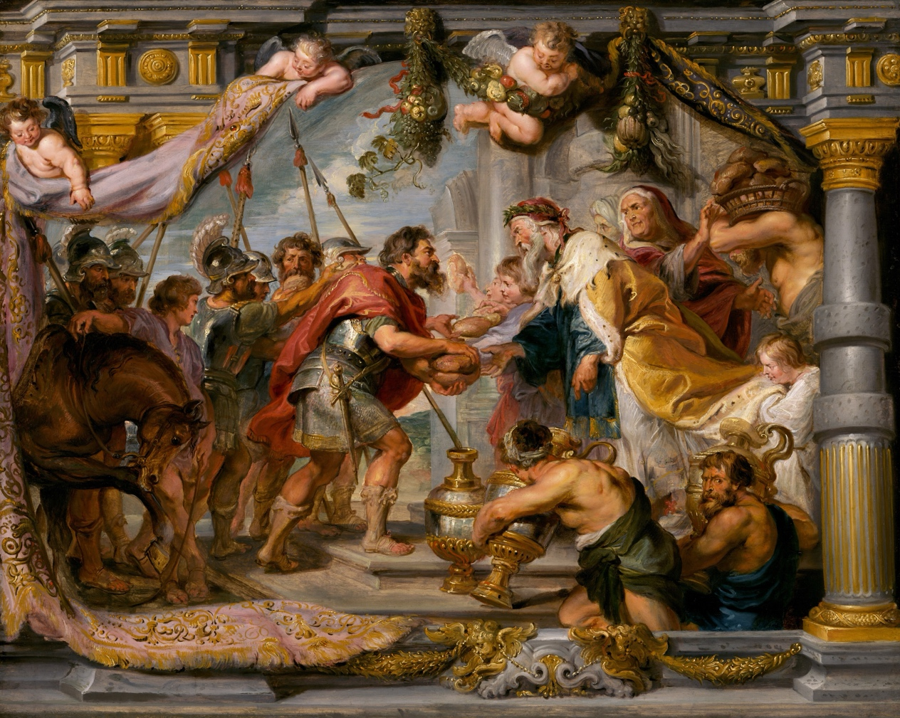
The Meeting of Abraham and Melchizedek by Peter Paul Rubens, 1626

Leader’s booklet

Meaning:
Jesus is greater. That’s the central message of Hebrews. Jesus is the greater word, the surer word, the final word. He is God’s full and final self-revelation. Why go anywhere else? Jesus brings us into lasting rest as the great high priest who bring a greater covenant by better blood shed in his greater sacrifice. Jesus is the fulfilment of all God’s promises for eternal rest from sin, temptation, and toil. He is sure hope. So why would we go anywhere else? He is the only one worth listening to, and the only one worth putting our trust in. And so we live for Jesus with lasting faith, fighting sin, bearing the disgrace he bore, and looking for the city to come.

Rationale:
In third term energy is often down, we need to get through the year, and we’re more likely to drift Christianly: that’s especially when we need Jesus! We need the comfort and rest in Jesus that the writer to the Hebrews explains so that we keep trusting Jesus, fighting sin, bearing disgrace, and looking ahead.

Jesus is Greater: Hebrews *Joseph | 1:1-2:4 | The Final Word
 | 2:5-18 | Hear the Word
 | 3:1-19 | Hold the Word
 | 4:1-13 | Lasting Rest
 | 4:14-5:10 | The Great High Priest
 | 5:11-6:20 | Don't Fall Away
 | 7:1-28 | The Greater Priest
 | 8:1-13 | The Greater Covenant
 | 9:1-28 | The Greater Blood
 | 10:1-18 | The Greater Sacrifice
 | 10:19-12:3 | Lasting Faith
 | 12:4-29 | Fighting Sin
 | 13:1-25 | Living Christianly
Sermon series:

Bible studies:
Study 1: The Final Word
God has spoken with finality by his Son, so be set on the word of the Son.

Pray

Launch: What are the most important voices in your life?

Read: Hebrews 1:1-14

Observation:
In a table, write down the keywords used to describe the angels and the Son.

Angels | The Son

Meaning:
The Son has Spoken 1:1-3
1 What is our source for revelation from God in these last days?

a What is the nature of God's speech through his Son?

b What can't be our source of revelation if God has spoken definitively through his Son?

2 What is this Son like?

a What can this Son not be like?

3 Who is this Son? Prove it!

The Son is Superior 1:4-14
4 How is the Son superior?

5 What does the writer to the Hebrews say Angels are?

a What beliefs about the Son and Angels might the writer be correcting?

6 If the Son is superior, what does that say about his words?

a What does that mean for the voices we listen to?

Application:
7 How should we respond to the superiority of the Son?

8 How should we not respond to the superiority of the Son?

]
Pray (10 minutes)

Study 2: Hear the Word
Hear the news: Jesus has made us God’s children, so live as Jesus has made us.

Pray

Launch: What's the most important thing you've heard in your life? (5 minutes)

Read: Hebrews 2:1-18

Observation:
In a table, write down what Jesus is like and what he does.

What Jesus:
Like | Does

Meaning:
Salvation vv1-4
1 What was the message of verse 2? (see context)

a What is the nature of this message?

b What about the nature of the message means that salvation should not be ignored?

2 How sure is this salvation?

3 So what will stop us from drifting away?

Subjected vv5-18
4 What is wrong with the world?

5 How is Jesus described as God's solution to the wrong in the world?

a What made Jesus the perfect solution?

b Why was it necessary for Jesus to be human in every way?

c How does that make us his brothers and sisters?

Application:
6 What are some of the best things about being God's children and Jesus' brothers and sisters for you?

7 How can we help one another pay careful attention to what we have heard?

Pray (10 minutes)

Study 3: Hold the Word
Jesus brings a greater covenant than Moses, so hold on to Jesus, don’t harden your hearts.

Pray

Launch: When were you exposed as incompetent?

Read: Hebrews 3:1-18

Observation:
With different colours, highlight everything said about Jesus, and the commands.

Meaning:
Jesus is greater vv1-6
1 What makes Jesus great?

a Jesus is our apostle or messenger. What does that mean for the angels in chapter two?

2 Why is Moses mentioned?

a How is Jesus greater than Moses?

i What does Jesus' relative greatness mean for us?

Hold on, don't harden vv7-19
3 What was so bad about the wilderness generation?

a Why is their example used?

b Why is the warning needed?

Application:
4 What causes you to drift from Jesus?

a What makes your heart hard?

5 What has convinced you to hold on rather than drift?

Pray

Study 4: Lasting Rest
The promise of entering God’s rest still stands, so make every effort enter that rest by the word.

Pray

Launch: What is your dream idea of rest?

Read: Hebrews 4:1-13

Observation:
Highlight the repeated words.

Meaning:
Warning v1-5
1 What is the warning?

a Why didn't the wilderness generation enter the promised rest?

b Why mightn't we enter the promised rest?

Sabbath-rest vv6-10
2 Is rest in the land possible if Joshua could not give them rest? Why/why not?

3 What does the quote from David tell us about when rest will come?

a When will rest come?

Word vv11-13
4 How should we respond to the news that rest is coming?

a What does it look like to 'make every effort'?

b How does God's word help us 'make every effort'?

5 If rest is for those who have faith but we should 'make every effort', how is that not salvation by works?

Application:
6 What then is this rest that the writer refers to?

7 How do we make every effort to enter God's rest?
Get practical

Pray

Study 5: The Great High Priest
Jesus is the perfect High Priest, so approach God through Jesus boldly.

Pray

Launch: What sayings or phrases have changed your life?

Read: Hebrews 4:14-5:10

Observation:
In different colours, highlight:
a What the priest is like
b What the priest does
c How we benefit/commands

Meaning:
Our High Priest 4vv14-16
1 How can Jesus truly empathise with us if he did not sin?

2 Why does Jesus' empathy give us confidence to approach God's throne?

The High Priests 5vv1-4
3 How were the high priests good representatives of the people?

a Why were the high priests inadequate in their ministry?

The High Priest 5vv5-10
4 What are Jesus' credentials as High Priest?

5 How can Jesus, who was sinless, be made perfect?

6 What is the relationship between Jesus' perfection and our obedience?

Application:
7 When do you feel like Jesus perfect work isn't enough to approach God in prayer?

8 How does this passage help us approach God in prayer when we feel like that?

Pray

Study 6: Don’t Fall Away
Salvation is sure in Jesus, so don’t fall away, be confident in him.

Pray

Launch: Who did you want to be like when you were growing up and why?

Read: Hebrews 5:11-6:20

Observation:
Identify the primary groups described in this chapter.

Meaning:
Sanctification 5v11-6v3
1 What is the Hebrews' problem?

2 What is the solution?

Salvation 6v4-12
3 How are the people of 5v11-6v3 compared to those of 6v4-8?

4 What isn't the Hebrews' problem?

5 How will they grow up into Jesus?

Surety 6v13-20
6 Why can they be sure that falling away isn't their problem?

Application:
7 How sure can they be? Why?

Pray
Study 7: The Greater Priest
Jesus is the eternal and perfect priest: we are saved completely through him.

Pray

Launch: Who is someone who has given you a boost of confidence at a major moment in your life?

Read: Hebrews 7:1-28

Observation:
Write a CV for Melchizedek and Jesus.

Meaning:
Great vv1-10
1 What is so unusual about Melchizedek?

2 How is it possible for Moses to be greater than Melchizedek?

Greatest vv11-28
3 Whose priesthood is Jesus' tied to to?

a Why might it make more sense to tie Jesus' priesthood to Levi/Aaron?

b So why is Jesus' priesthood tied to Melchizedek's priesthood?

4 Why is it necessary for Jesus to be in the order of Melchizedek?

a What does this tell us about Jesus' priestly ministry?

b What does this tell us about the covenant Jesus brought about?

5 What does it thus mean for Jesus to live to intercede?

Application:
6 When have you doubted your salvation? Why?

a How does Jesus' priestly ministry encourage us in those times?

Pray

Study 8: The Greater Covenant
Jesus covenant is greater: praise God for the new covenant.

Pray

Launch: What is one new purchase you made that improved your life substantially?

Read: Hebrews 8:1-13

Observation:
In two separate tables, list the characteristics of the old and new priests, and the old and new covenants.

Old priests | New priests
Old covenant | New covenant

Meaning:
Old vs new priests vv1-6
1 How would you describe the old and the new priests?

2 Why was the old priesthood imperfect?

3 What makes Jesus' priesthood perfect?

Old vs New covenants vv7-13
Say: this section quotes Jeremiah 31.
4 Why are the people the problem rather than the covenant?

a What does God do in response?

b How is God's turning from his people even fair?

5 Who is included in the covenant?

a Israel was wiped off the map in Jeremiah's and the Hebrews time. How is this inclusion possible?

6 How will the new covenant solve the problems of the old covenant?

Application:
7 What is the place of the works of the old covenant for us then?

8 What is your emotional response to the news of the new covenant?

Pray

Study 9: The Greater Blood
Jesus’ shed blood won a permanent salvation: praise God that our consciences are cleansed from sin and guilt by Jesus’ shed blood!

Pray

Launch: What causes you to be uncertain about things in life? (5 minutes)

Read: Hebrews 9:1-28

Observation:
Create a labelled diagram of 9v1-7.

Meaning:
Old Tabernacle, Offered Blood vv1-14
1 What was the purpose of the old tabernacle?

2 What was the problem with the old tabernacle?

3 How did Jesus obtain redemption?

a How is his redemption eternal?

4 What does it mean for Jesus to be both the High Priest and the blood sacrifice?

5 How does Jesus' shed blood cleanse our consciences?

Heavenly Tabernacle, Better Blood vv15-28
6 How sure can we be that we'll receive the eternal inheritance? Why?

Application:
7 When do you feel unsure in your conscience that you'll receive the inheritance?

a What confidence do we have that our consciences are cleansed in those times?

b What confidence does that give us?

Pray
Praise God that our consciences have been cleansed form sin and guilt!

Study 10: The Greater Sacrifice
Jesus made us perfect by his once for all sacrifice: he has made us enough!

Pray

Launch: What makes you feel inadequate? (5 minutes)

Read: Hebrews 10:1-18

Observation:
Highlight the repeated words in triplets.

Meaning:
Old Sacrifices vv1-4
1 What did the sacrifices:
a Not achieve?

b Actually achieve?

2 Why couldn't the blood of bulls and goats make someone perfect?

New Sacrifice Foretold vv5-10
3 If God did not desire sacrifices, how is Jesus' sacrifice any good?

4 Jesus' coming and his sacrifice was written about in the Old Testament. What are the implications for:
a The Law?

b The Israelites?

c Us?

New Sacrifices Unnecessary vv11-18
5 What does our perfection suggest about Jesus' work?

a How does that qualify him to sit at the right hand of God?

6 Will it be possible for us to fall away from perfection? Why/why not?

Application:
7 How does this chapter encourage us when we don't feel like we're enough?

Pray

Study 11: Lasting Faith
Faith is the required response to all God has done in Jesus, so run the race with persevering faith.

Pray

Launch: What do people put their faith in? Share stories. (5 minutes)

Read: Hebrews 10:19-12:3

Observation:
Highlight the word faith and faithful in one colour; highlight names in another colour.

Meaning:
Hold On 10vv19-39
1 How can we be sure that we belong in the Most Holy Place?

a Why can we be sure?

2 Why the warning about sin in a conversation about faith?

a How does this warning motivate you to kill sin and hold on to faith?

With Faith 11v1-12v3
3 Pay attention to some of the names. What do you know about these people?

a What do their stories say about personal faith and the faithfulness of God?

4 Why is Jesus the best example of faith?

a What does it mean for Jesus to be the pioneer and perfector of faith?

b How does his life give us hope in our struggle against sin?

Application:
5 How can our Sunday gatherings better help us to:
a kill sin and hold on with faith?

b Help us look to Jesus as the pioneer and perfector of faith?

Pray

Study 12: Fighting Sin
We have been made holy, so live as holy people.

Pray

Launch: Tell us about a project you undertook that required your all?

Read: Hebrews 12:4-29

Observation:
Highlight the repeated words.

Meaning:
Living as Holy People vv4-17
1 What's your initial reaction to these words about God's discipline?

a What could the writer mean by 'resisting sin to the point of shedding blood'?

b How does that compare with out usual approach to sin?

c So why is God's discipline good?

2 How do we live as God's holy people?

a Why is Esau's example so poignant given what we’ve seen so far in Hebrews?

In the Presence of the Holy One vv18-29
3 What are the differences between Mt Sinai and Mount Zion?

a What do both mountains have in common?

b What do we have in common with the Israelites?

4 What confidence can we have the Israelites didn't know?

a How should we respond to God for his gift?

Application:
5 How can we strengthen one another to live as God's holy people this week?

Pray

Study 13: Living Christianly
Live to praise God by loving others.

Pray

Launch: What makes teams work well together?

Read: Hebrews 13:1-25

Observation:
List all the commands.

Meaning:
1 What seems to tie all these commands together?

Loving Others at Home vv1-6
2 What instructions do you find the easiest?

3 What instructions do you find the most difficult?

Loving Others at Church vv7-19
4 How can we love our leaders well?

a Why does the steadfastness of Jesus mean that our leader’s faith is worth imitating?

5 How do we stand strong on good teaching?

a How does this help our leaders?

Benediction vv20-25
6 Who is ultimately equipping us, though?

Application:
7 How can we help each other grow where we need to?

Pray
Use vv20-25 to guide your prayers.

